Binary Search Tree: https://www.geeksforgeeks.org/introduction-to-binary-search-tree/

Problem: https://leetcode.com/problems/search-in-a-binary-search-tree/description/
C++
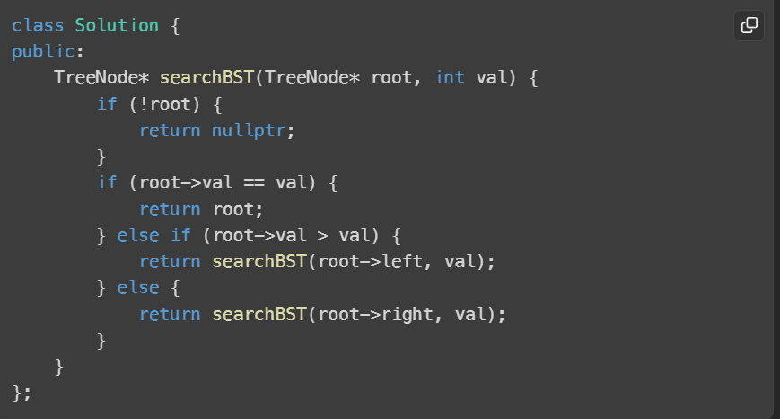
Python:
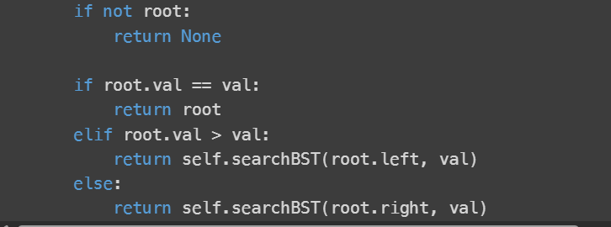

Java:
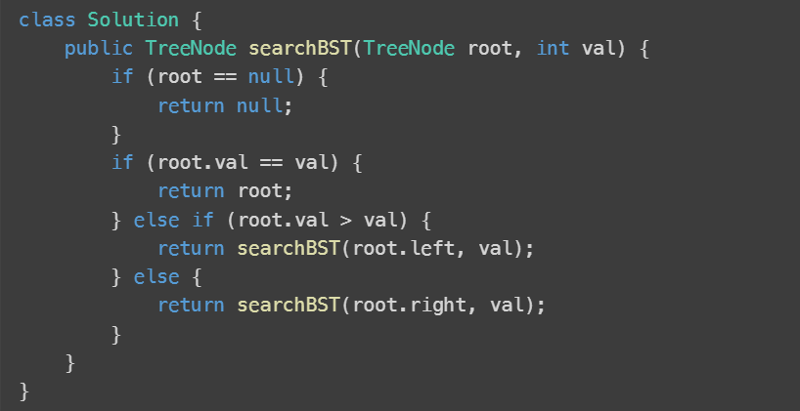

Problem : https://www.geeksforgeeks.org/problems/insert-a-node-in-a-bst/1
C++
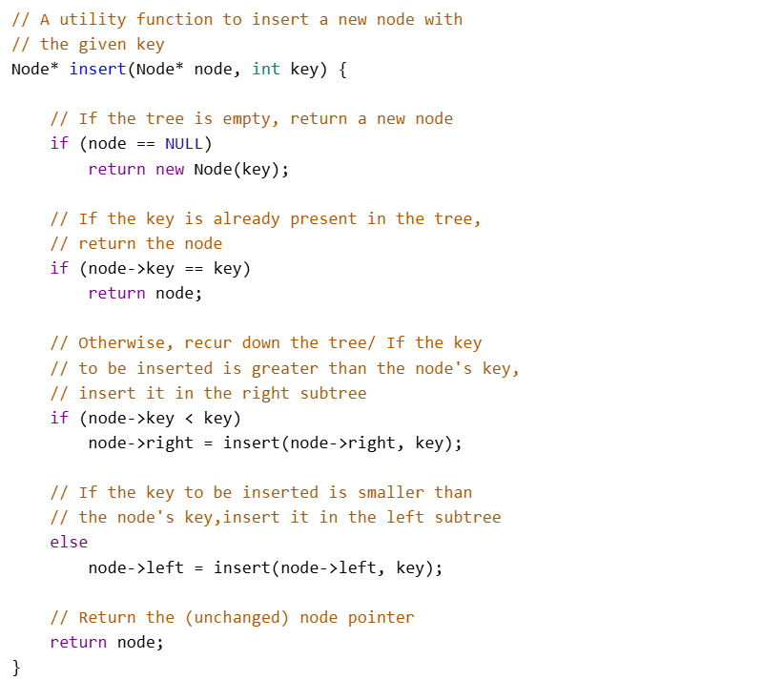

Java:
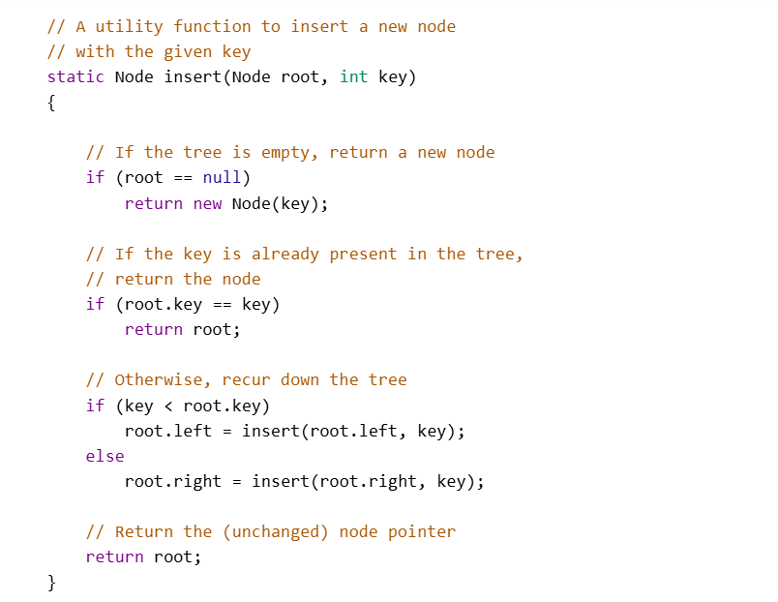
Python:
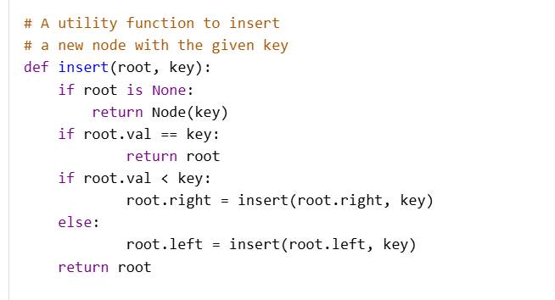

Problem: https://www.geeksforgeeks.org/problems/implementing-ceil-in-bst/1

C++
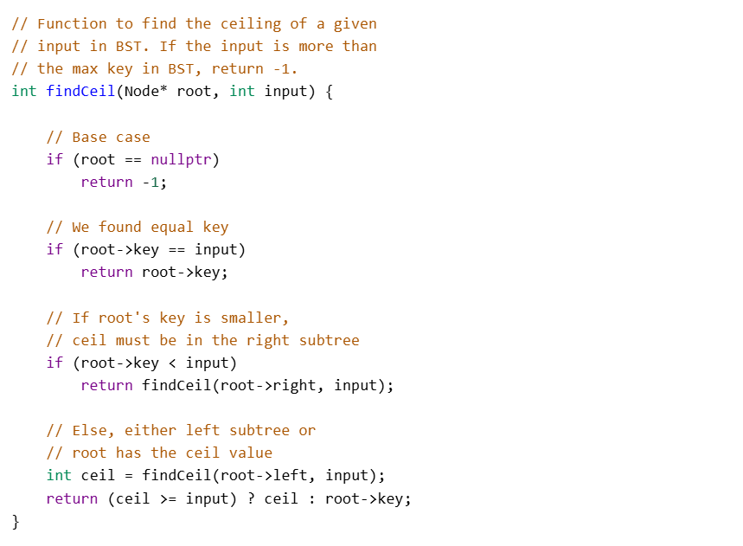
Java:
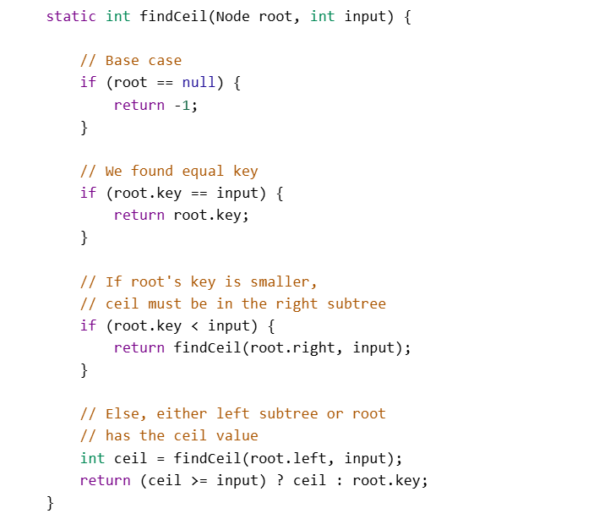

Python:
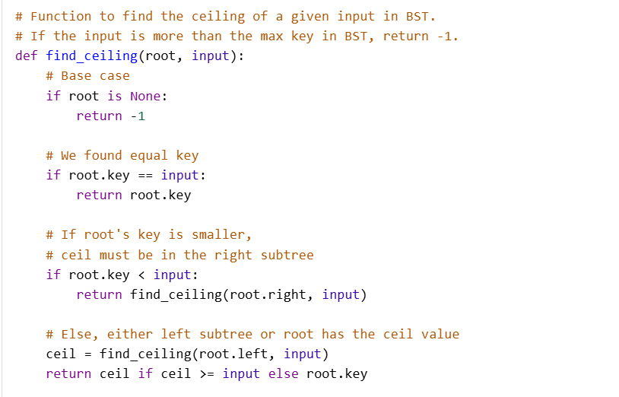

Problem:
https://www.geeksforgeeks.org/problems/check-for-bst/1

c++
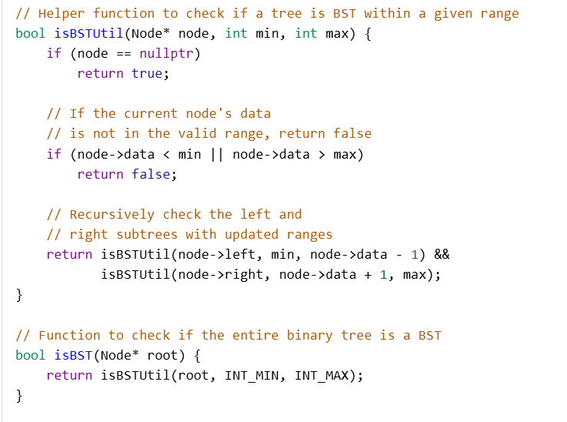
Java:
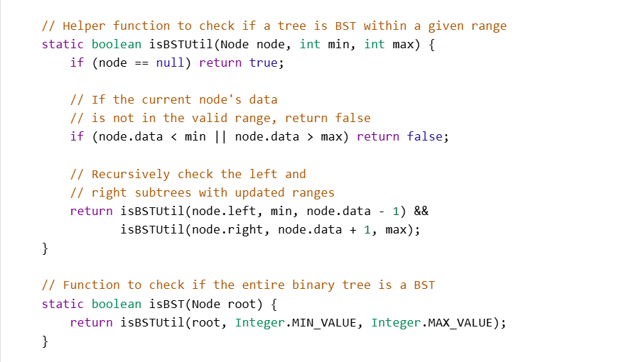

Python:
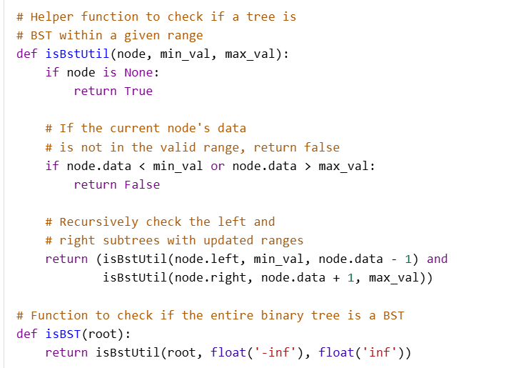

Topic - Heaps:
https://www.geeksforgeeks.org/heap-data-structure/

Min - Heap:
https://www.geeksforgeeks.org/introduction-to-min-heap-data-structure/

Max-Heap: https://www.geeksforgeeks.org/introduction-to-max-heap-data-structure/

Heap Sort: https://www.geeksforgeeks.org/heap-sort/

Problem: https://www.geeksforgeeks.org/problems/kth-smallest-element5635/1

C++
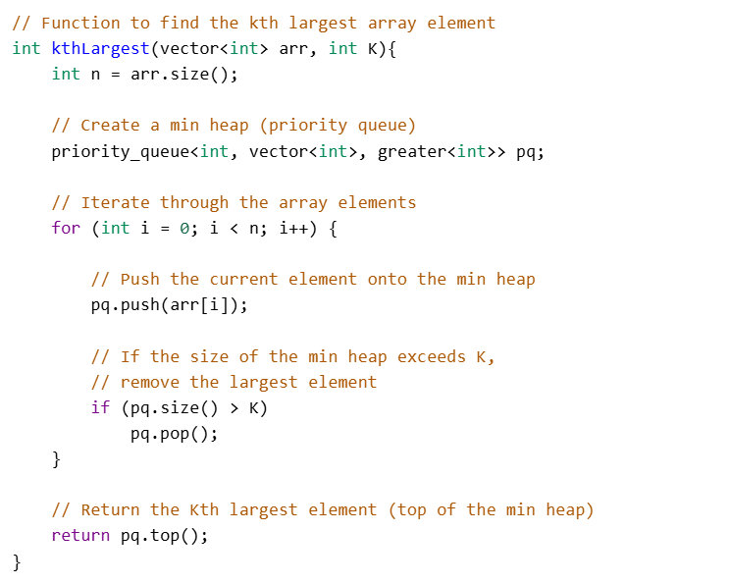
Java:
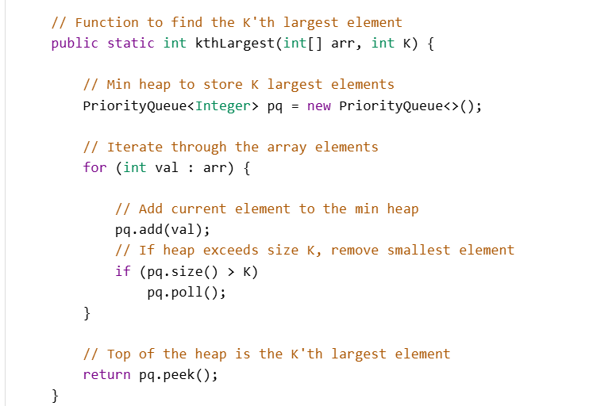
Python:
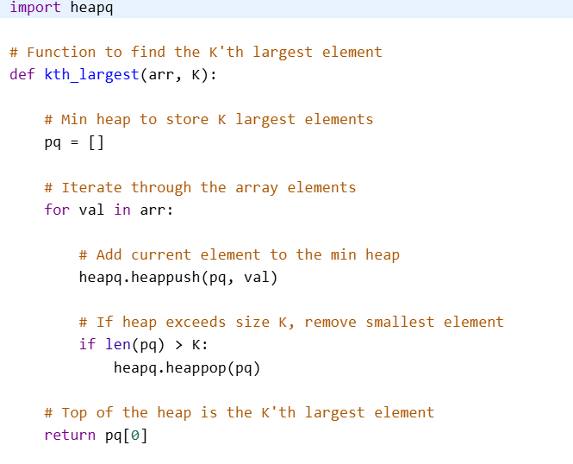

Problem:
https://www.geeksforgeeks.org/problems/top-k-frequent-elements-in-array/1
C++
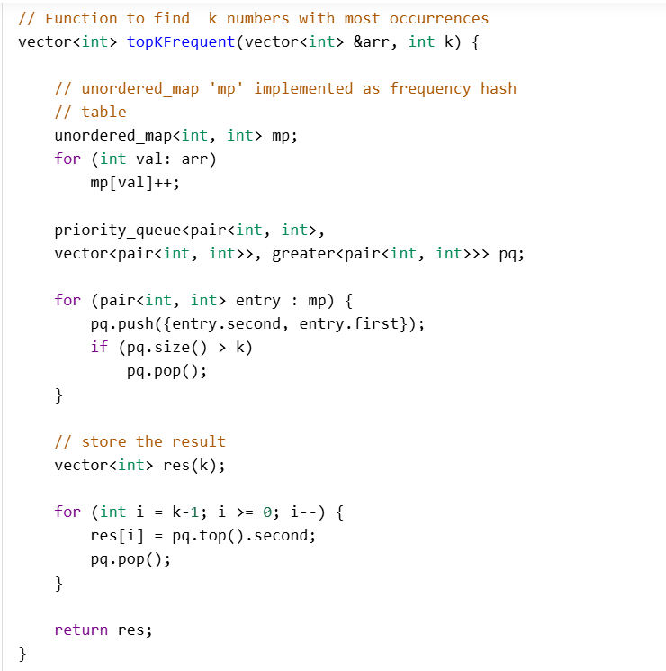

Java:
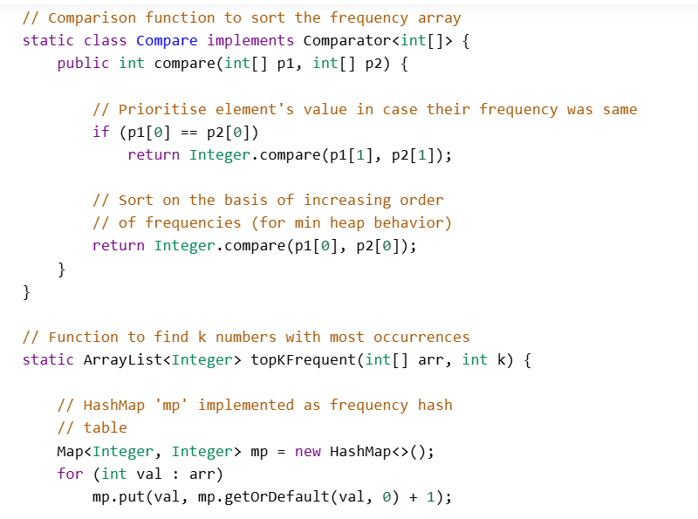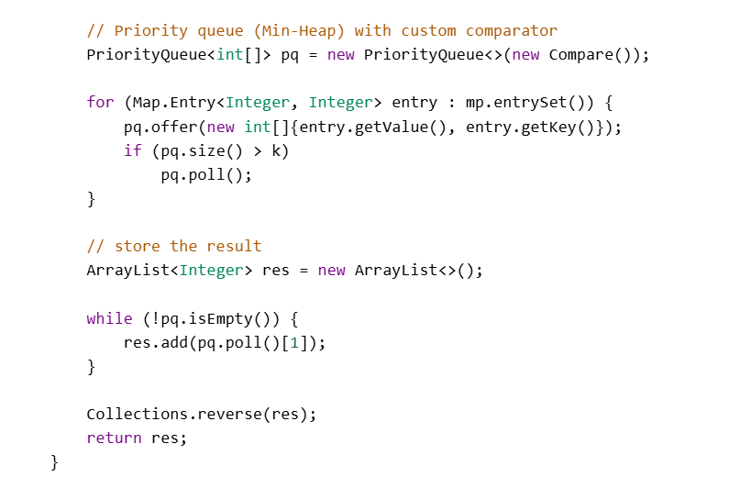

Python:
